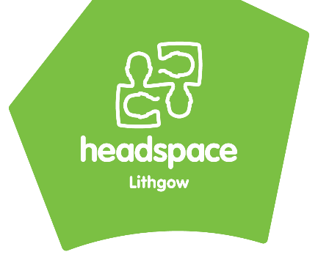
headspace Lithgow Referral Form
Once completed please email to: hs.Lithgow@marathonhealth.com.au

This referral is for…..  - Mental health wellbeing?  - Headspace Lithgow  - Youth+ Program  - Alcohol & other drug support  - Physical and/or sexual health support  - Work & Study Support?  - Youth Beyond the Flame Vocation Support | For information on service options please head to our website:  www. headspace.org.au/headspace-centres/lithgow/
Do you believe this young person is at urgent risk of harm to themselves or other people? ☐ Yes ☐ No
IF YES, STOP! If the young person is currently at risk of harm to themselves or to someone else, they are not suitable for headspace services. Please contact the mental health hotline on 1800 011 511 (24 hours) for appropriate services, take them to your nearest hospital, or call 000.

Client information….
Young persons preferred name:
Young person’s last name:
Are they known by any other names?
date of birth: |  |  |  |  |  | age:
gender: |  |  |  |  |  | pronouns:
Does the young person identify as: |  |  | ☐ Aboriginal ☐ Torres Strait Islander ☐ Both ☐ Non-Indigenous  ☐ Other: ________________________
Language other than English spoken at home: |  |  |  |  | Interpreter needed?
Residential address: |  | Street:  Suburb: |  |  |  | Postcode:
Who with? | ☐ At home with family ☐ Living alone ☐ Homeless  ☐ Staying with friends ☐ supported accommodation ☐ Refuge
Phone number: |  |  |  | Email (optional):

Reason(s) for referral….
Presenting Issues/Reason for referral: Please attach any relevant assessment notes, and/or discharge summaries

Any previous mental health support / treatment, counselling, medication or diagnoses?

What does the young person feel would be useful about coming to headspace, what are their goals? How motivated are they to come?

Any other information that may be relevant? (e.g. family history of mental health issues, client history, court involvement, disability)

Safety considerations (please note these are not exclusion criteria) ….
Suicidal ideation? ☐ yes ☐ no
If yes, details:

Non-accidental self-injury? ☐ yes ☐ no
If yes, details:

Substance use? ☐ yes ☐ no
If yes, details:

At risk of homelessness? ☐ yes ☐ no
Details:

Risk talking and/or impulsive behaviour? ☐ yes ☐ no
If yes, details:

Additional details….
Does YP have a GP? Doctors name:
Medical centre / Practice:
Is there a current Mental Health Treatment Plan? | ☐ yes ☐ no
Does the young person have an NDIS plan? | ☐ yes ☐ no
Any other workers/services involved?

Name of parent/guardian:
Parent/guardian contact number:
best person to contact about this referral: | ☐ Young person ☐ Parent/Guardian ☐ Referrer

Consent….
Please note that for headspace Lithgow to accept this referral….
Is the Young person aged between 12 and 25 years of age?
- Yes

Is the Young person aware of and consent to this referral being made?
- Yes – verbal consent was given. (Date)____________

- Yes – (Client signature) _________________________ (Date)____________

If the client is under the age of 16, we require consent of both the young person and their parent/guardian.
Is the parent/guardian person aware of and consent to this referral being made?
- Yes – verbal consent was given. (Date)____________

- Yes – (parent/guardian signature) _________________________ (Date)____________

Referrers details….
Name: | Position / Organization:
Email: | Best contact number:
_______________________ ________________________ ___________
Referrer name Referrer signature Date

